

**prediction of heart disease USING DATA MINING**

# **GROUP MEMBERS:**

1. P19101064 – **SHAHID IQBAL**
2. P19101063 – **SANA ASHFAQ**
3. P19101025 – **IQRA MEHDI**
4. P19101008 – **ANUM ZEHRA (GROUP LEAD)**

# **SUPERVISOR:**

DR. TAHSEEN A. JILANI

# **PROJECT DETAILS:**

MCS MORNING (FINAL)

DATA MINING AND DATA WAREHOUSING

WORKING ON WEKA AND SPSS

# **ABSTRACT:**

Our project is to predict the heart disease by examining the various attributes. In this project diverse strategies have been utilized to detect heart disease such as Decision tree, K-Means, Confusion Matrix. And among all these calculations the final result gives us the finest precision of 91.8%.

# TABLE OF CONTENT

GROUP MEMBERS 1

SUPERVISOR 1

PROJECT DETAILS 1

ABSTRACT 1

TABLE OF CONTENT 2

1. INTRODUCTION 3

2. DECISION TREE 4

2.1. INTRODUCTION 4

2.2. ADVANTAGES 4

2.3. DISADVANTAGES 4

3. TREE ALGORITHMS: ID3, C4.5 5

3.1. ID3 (ITERATIVE DICHOTOMISER 3) 5

4. LOGISTIC REGRESSION 5

5. DATA VISUALIZATION 11

5.1. ALL ATTRIBUTES WRT HEART DISEASE 11

5.2. C4.5 IMPLEMENTATION IN WEKA USING JAVA LIBRARY J48 11

5.3. AGE VS HEART DISEASE 12

5.4. SEX VS HEART DISEASE 12

5.5. CHEST PAIN TYPE VS HEART DISEASE 13

5.6. BP VS HEART DISEASE 13

5.7. CHOLESTROL VS HEART DISEASE 14

5.8. FBS OVER 120 VS HEART DISEASE 14

5.9. EKG RESULTS VS HEART DISEASE 15

5.10. MAX HR VS HEART DISEASE 15

5.11. EXERCISE ANGINA VS HEART DISEASE 16

5.12. ST DEPRESSION VS HEART DISEASE 16

5.13. SLOPE OF ST VS HEART DISEASE 17

5.14. NO. OF VESSELS FLURO VS HEART DISEASE 17

5.15. THALLIUM VS HEART DISEASE 18

5.16. PLOT MATRIX....................................................................................................................20

6. MODEL DETAILS............................................................................................................................21

6.1. COMPARISON...................................................................................................................21

7.CONCLUSION & REFERNCES.........................................................................................................22

# **INTRODUCTION:**

In daily life many factors influence a human heart. Many problems are happening at a fast pace and new heart diseases are rapidly being recognized. In today’s world of stress Heart, being an essential organ in a human body which pumps blood through the body for the blood circulation is fundamental and its health is to be conserved for a sound living. The health of a human heart is based on the encounters in a person’s life and is completely dependent on proficient and personal behaviors of a person. There may also be a few genetic factors through which a sort of heart illness is passed down from eras. Concurring to the World Health Organization, every year more than 12 million deaths are happening around the world due to the different sorts of heart diseases which is additionally known by the term cardiovascular disease. The term heart disease includes numerous diseases that are diverse and particularly affect the heart and the arteries of a human being. Even youthful matured individuals around their 20-30 a long time of life expectancy are getting influenced by heart diseases. The increment within the possibility of heart disease among young may be due to the bad eating habits, lack of rest, anxious nature, depression, discouragement and various other factors such as obesity, poor diet, family history, high blood pressure, high blood cholesterol, idle behavior, smoking and hypertension.

The diagnosis of the heart diseases could be an exceptionally important and is itself the most complicated task in the medical field. All the mentioned components are taken into consideration when analyzing and understanding the patients by the specialist through manual check-ups at regular intervals of time. The symptoms of heart disease significantly depend upon which of the distress felt by a person. A few side effects are not usually identified by the common people. However, common symptoms include chest pain, breathlessness, and heart palpitations. The chest pain common to many types of heart disease is known as angina, or angina pectoris, and happens when a portion of the heart does not get sufficient oxygen. Angina may be activated by stressful events or physical effort and normally lasts under 10 minutes. Heart attacks can also happen as a result of different types of heart disease.

Data Mining is an important decision-making process information from past collections for future analysis or forecast. Information may be anonymous and may not be identified without using a data mine. The section says a single data mining process where the future result or predictions can be made based on historical data i.e., available. Digging for medical data has created a possible solution

combine classification techniques and deliver by computer database training that leads continuously to hidden tests patterns in medical data sets used for prediction of the patient's future status. So, using medical data to dig it is able to provide information about patient history and is capable provided clinical support through analysis. Clinical analysis in patients, these patterns are very important. In English, medical data mining uses classification algorithms that is an important part of diagnosing the possibility of a heart attack before it happened. Separation algorithms can be trained and tested to make decisive predictions a person's condition of heart attack.

# **DECISION TREE:**

## **INTRODUCTION:**

Decision Trees (DTs) are a non-parametric supervised learning method used for classification and regression. The goal is to create a model that predicts the value of a target variable by learning simple decision rules inferred from the data features. A tree can be seen as a piecewise constant approximation.

For instance, in the example below, decision trees learn from data to approximate a sine curve with a set of if-then-else decision rules. The deeper the tree, the more complex the decision rules and the fitter the model.

## **ADVANTAGES:**

Some advantages of decision trees are:

Simple to understand and to interpret. Trees can be visualized. Requires little data preparation. Other techniques often require data normalization, dummy variables need to be created and blank values to be removed. Note however that this module does not support missing values. The cost of using the tree (i.e., predicting data) is logarithmic in the number of data points used to train the tree. Able to handle both numerical and categorical data. However, scikit-learn implementation does not support categorical variables for now. Other techniques are usually specialized in analyzing datasets that have only one type of variable. See algorithms for more information. Able to handle multi-output problems. To account for the reliability of the model. Performs well even if its assumptions are somewhat violated by the true model from which the data were generated.

## **DISADVANTAGES:**

Some disadvantages of decision trees are:

Decision-tree learners can create over-complex trees that do not generalize the data well. This is called overfitting. Mechanisms such as pruning, setting the minimum number of samples required at a leaf node or setting the maximum depth of the tree are necessary to avoid this problem. Decision trees can be unstable because small variations in the data might result in a completely different tree being generated. This problem is mitigated by using decision trees within an ensemble. Predictions of decision trees are neither smooth nor continuous, but piecewise constant approximations as seen in the above figure. Therefore, they are not good at extrapolation. The problem of learning an optimal decision tree is known to be NP-complete under several aspects of optimality and even for simple concepts. Consequently, practical decision-tree learning algorithms are based on heuristic algorithms such as the greedy algorithm where locally optimal decisions are made at each node. Such algorithms cannot guarantee to return the globally optimal decision tree. This can be mitigated by training multiple trees in an ensemble learner, where the features and samples are randomly sampled with replacement. There are concepts that are hard to learn because decision trees do not express them easily, such as XOR, parity or multiplexer problems. Decision tree learners create biased trees if some classes dominate. It is therefore recommended to balance the dataset prior to fitting with the decision tree.

# **TREE ALGORITHMS: ID3, C4.5**

What are all the various decision tree algorithms and how do they differ from each other? Which one is implemented in scikit-learn?

## **ID3 (ITERATIVE DICHOTOMISER 3)**

It was developed in 1986 by Ross Quinlan. The algorithm creates a multiway tree, finding for each node (i.e., in a greedy manner) the categorical feature that will yield the largest information gain for categorical targets. Trees are grown to their maximum size and then a pruning step is usually applied to improve the ability of the tree to generalize to unseen data.

* 1. **C4.5**

It is the successor to ID3 and removed the restriction that features must be categorical by dynamically defining a discrete attribute (based on numerical variables) that partitions the continuous attribute value into a discrete set of intervals. C4.5 converts the trained trees (i.e., the output of the ID3 algorithm) into sets of if-then rules. This accuracy of each rule is then evaluated to determine the order in which they should be applied. Pruning is done by removing a rule’s precondition if the accuracy of the rule improves without it.

# **LOGISTIC REGRESSION**

In statistics, multinomial logistic regression is a classification method that generalizes logistic regression to multiclass problems, i.e., with more than two possible discrete outcomes.Thatis, it is a model that is used to predict the probabilities of the different possible outcomes of a categorically distributed dependent variable, given a set of independent variables (which may be real-valued, binary-valued, categorical-valued, etc.) and used to describe data and to explain the relationship between one dependent binary variable and one or more nominal, ordinal, interval or ratio-level independent variables.

Sometimes Logistic regressions are difficult to interpret; the Intellectus Statistics tool easily allows you to conduct the analysis, then in plain English interprets the output.

NOM REG Heart Disease (BASE=LAST ORDER=ASCENDING) WITH Age Sex ChestPainType BP Cholesterol

FBSOver120 EKGResultsMaxHRExcerciseAnginaSTDepressionSlopeOfSTNoOfVesselsFluro Thallium

/CRITERIA CIN(95) DELTA(0) MXITER(100) MXSTEP(5) CHKSEP(20) LCONVERGE(0) PCONVERGE(0.000001)

SINGULAR(0.00000001)

/MODEL

/STEPWISE=PIN(.05) POUT(0.1) MINEFFECT(0) RULE(SINGLE) ENTRYMETHOD(LR) REMOVALMETHOD(LR)

/INTERCEPT=INCLUDE

/PRINT=FIT PARAMETER SUMMARY LRT CPS STEP MFI.

**Nominal Regression**

|  |  |  |
| --- | --- | --- |
| **Notes** | | |
|  | |  |
| Comments | |  |
| Input | Data | C:\Users\jojo \Desktop\HeartDisease.sav |
| Active Dataset | DataSet1 |
| Filter | <none> |
| Weight | <none> |
| Split File | <none> |
| N of Rows in Working Data File | 270 |
| Missing Value Handling | Definition of Missing | User-defined missing values are treated as missing. |
| Cases Used | Statistics are based on all cases with valid data for all variables in the model. |
| Syntax | | NOMREG HeartDisease (BASE=LAST ORDER=ASCENDING) WITH Age Sex ChestPainType BP Cholesterol  FBSOver120 EKGResultsMaxHRExcerciseAnginaSTDepressionSlopeOfSTNoOfVesselsFluro Thallium  /CRITERIA CIN(95) DELTA(0) MXITER(100) MXSTEP(5) CHKSEP(20) LCONVERGE(0) PCONVERGE(0.000001)  SINGULAR(0.00000001)  /MODEL  /STEPWISE=PIN(.05) POUT(0.1) MINEFFECT(0) RULE(SINGLE) ENTRYMETHOD(LR) REMOVALMETHOD(LR)  /INTERCEPT=INCLUDE  /PRINT=FIT PARAMETER SUMMARY LRT CPS STEP MFI. |
| Resources | Processor Time | 00:00:00.08 |
| Elapsed Time | 00:00:00.08 |

|  |
| --- |
| **Warnings** |
| There are 270 (50.0%) cells (i.e dependent variable levels by subpopulations) with zero frequencies. |

|  |  |  |  |
| --- | --- | --- | --- |
| **Case Processing Summary** | | | |
|  | | N | Marginal Percentage |
| HeartDisease | 0 | 150 | 55.6% |
| 1 | 120 | 44.4% |
| Valid | | 270 | 100.0% |
| Missing | | 0 |  |
| Total | | 270 |  |
| Subpopulation | | 270a |  |

|  |
| --- |
| a. The dependent variable has only one value observed in 270 (100.0%) subpopulations. |

|  |  |  |  |  |
| --- | --- | --- | --- | --- |
| **Model Fitting Information** | | | | |
| Model | Model Fitting Criteria | Likelihood Ratio Tests | | |
| -2 Log Likelihood | Chi-Square | df | Sig. |
| Intercept Only | 370.959 |  |  |  |
| Final | 179.598 | 191.361 | 13 | .000 |

|  |  |  |  |
| --- | --- | --- | --- |
| **Goodness-of-Fit test:** | | | |
|  | Chi-Square | Df | Sig. |
| Pearson | 232.117 | 256 | .856 |
| Deviance | 179.598 | 256 | 1.000 |

|  |  |
| --- | --- |
| **Pseudo R-Square** | |
| Cox and Snell | .508 |
| Nagelkerke | .680 |
| McFadden | .516 |

|  |  |  |  |  |
| --- | --- | --- | --- | --- |
| **Likelihood Ratio Tests** | | | | |
| Effect | Model Fitting Criteria | Likelihood Ratio Tests | | |
| -2 Log Likelihood of Reduced Model | Chi-Square | df | Sig. |
| Intercept | 187.628 | 8.031 | 1 | .005 |
| Age | 180.063 | .465 | 1 | .495 |
| Sex | 188.408 | 8.810 | 1 | .003 |
| ChestPainType | 191.342 | 11.744 | 1 | .001 |
| BP | 184.646 | 5.048 | 1 | .025 |
| Cholesterol | 182.847 | 3.249 | 1 | .071 |
| FBSOver120 | 181.571 | 1.973 | 1 | .160 |
| EKGResults | 181.956 | 2.358 | 1 | .125 |
| MaxHR | 183.687 | 4.089 | 1 | .043 |
| ExcerciseAngina | 183.262 | 3.664 | 1 | .056 |
| STDepression | 181.947 | 2.349 | 1 | .125 |
| SlopeOfST | 180.862 | 1.264 | 1 | .261 |
| NoOfVesselsFluro | 202.822 | 23.224 | 1 | .000 |
| Thallium | 190.248 | 10.650 | 1 | .001 |

|  |
| --- |
| The chi-square statistic is the difference in -2 log-likelihoods between the final model and a reduced model. The reduced model is formed by omitting an effect from the final model. The null hypothesis is that all parameters of that effect are 0. |

|  |  |  |  |  |  |  |  |  |  |
| --- | --- | --- | --- | --- | --- | --- | --- | --- | --- |
| **Parameter Estimates** | | | | | | | | | |
| HeartDiseasea | | B | Std. Error | Wald | df | Sig. | Exp(B) |  |  |
|  |  |
| 0 | Intercept | 8.446 | 3.088 | 7.481 | 1 | .006 |  |  |  |
| Age | .017 | .026 | .462 | 1 | .497 | 1.018 |  |  |
| Sex | -1.542 | .541 | 8.132 | 1 | .004 | .214 |  |  |
| ChestPainType | -.701 | .215 | 10.600 | 1 | .001 | .496 |  |  |
| BP | -.025 | .011 | 4.850 | 1 | .028 | .975 |  |  |
| Cholesterol | -.007 | .004 | 3.142 | 1 | .076 | .993 |  |  |
| FBSOver120 | .795 | .575 | 1.913 | 1 | .167 | 2.214 |  |  |
| EKGResults | -.302 | .198 | 2.325 | 1 | .127 | .740 |  |  |
| MaxHR | .021 | .011 | 3.957 | 1 | .047 | 1.021 |  |  |
| ExcerciseAngina | -.829 | .431 | 3.701 | 1 | .054 | .436 |  |  |
| STDepression | -.344 | .227 | 2.291 | 1 | .130 | .709 |  |  |
| SlopeOfST | -.442 | .391 | 1.279 | 1 | .258 | .643 |  |  |
| NoOfVesselsFluro | -1.165 | .269 | 18.726 | 1 | .000 | .312 |  |  |
| Thallium | -.341 | .106 | 10.359 | 1 | .001 | .711 |  |  |

# **DATA VISUALIZATION:**

## **ALL ATTRIBUTES WRT HEART DISEASE**

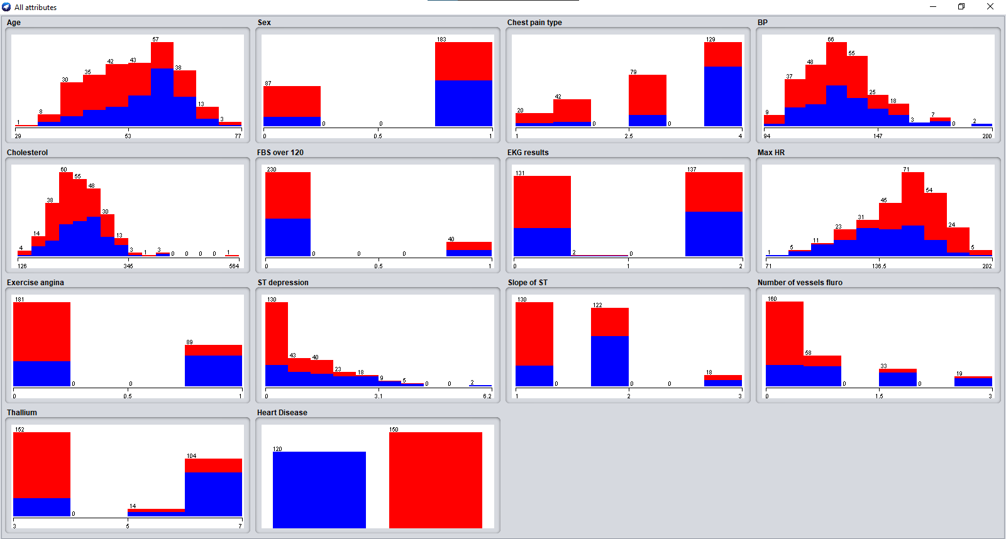

## **C4.5 IMPLEMENTATION IN WEKA USING JAVA LIBRARY J48:**

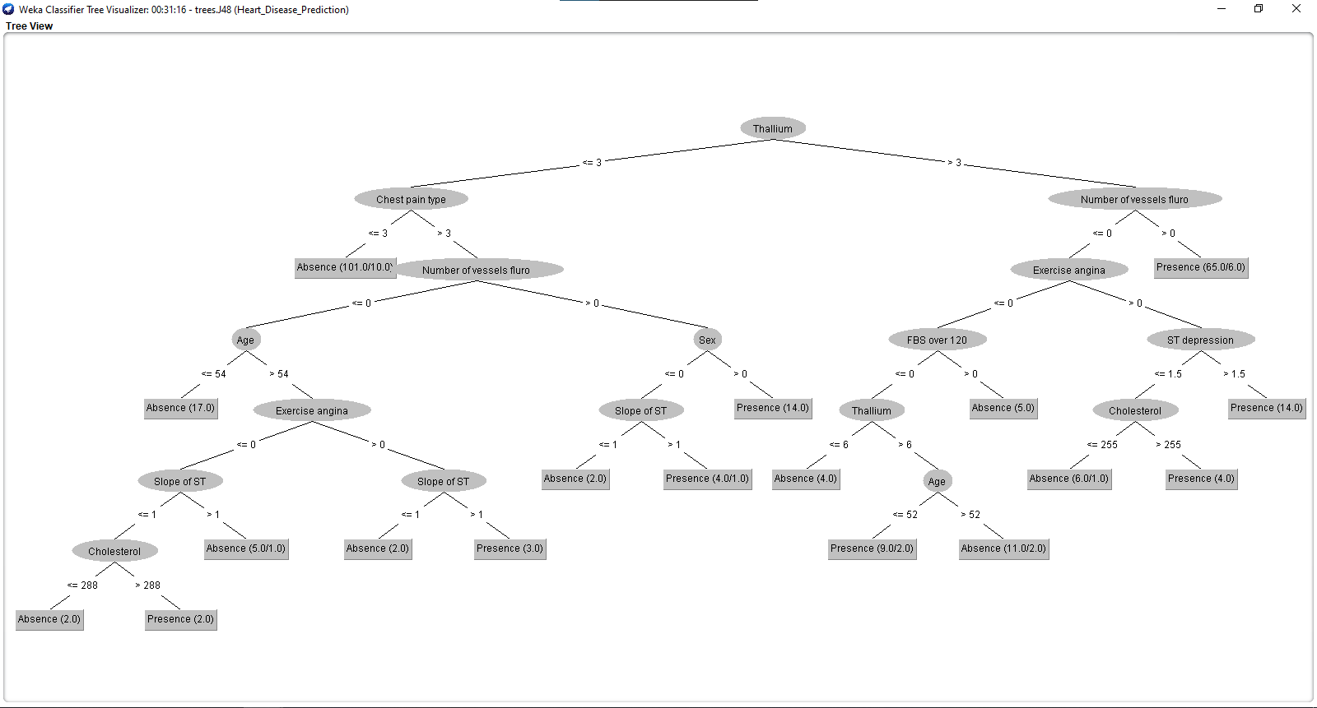

## **AGE VS HEART DISEASE:**

**Heart disease doesn’t happen just to older adults. It is happening to younger adults more and more often. This is partly because the conditions that lead to heart disease are happening at younger ages.**

Heart disease—and the conditions that lead to it—can happen at any age.

High rates of obesity and high blood pressure among younger people (ages 35–64) are putting them at risk for heart disease earlier in life.

Nearly half of all Americans have at least one of the top three risk factors for heart disease: high blood pressure, high cholesterol, and smoking.

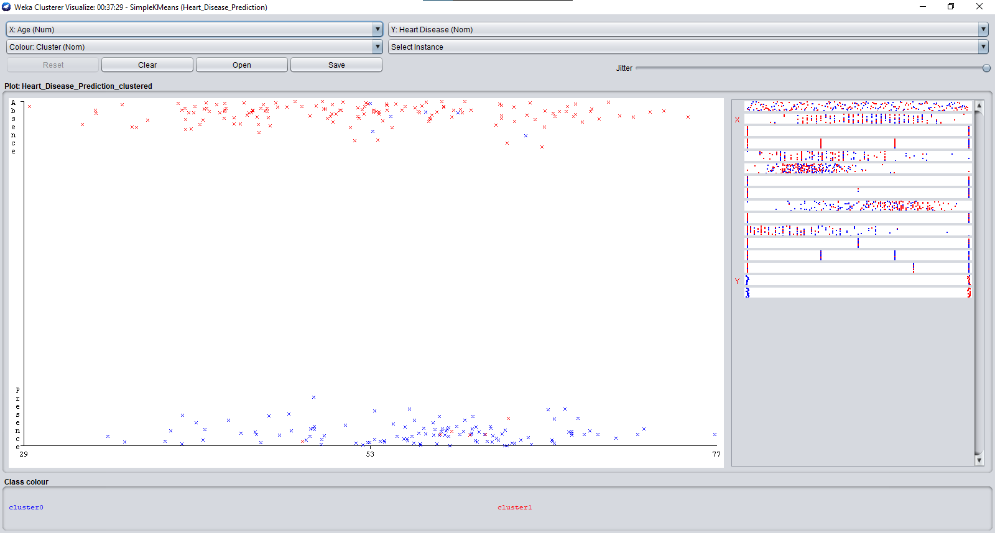

## **SEX VS HEART DISEASE:**

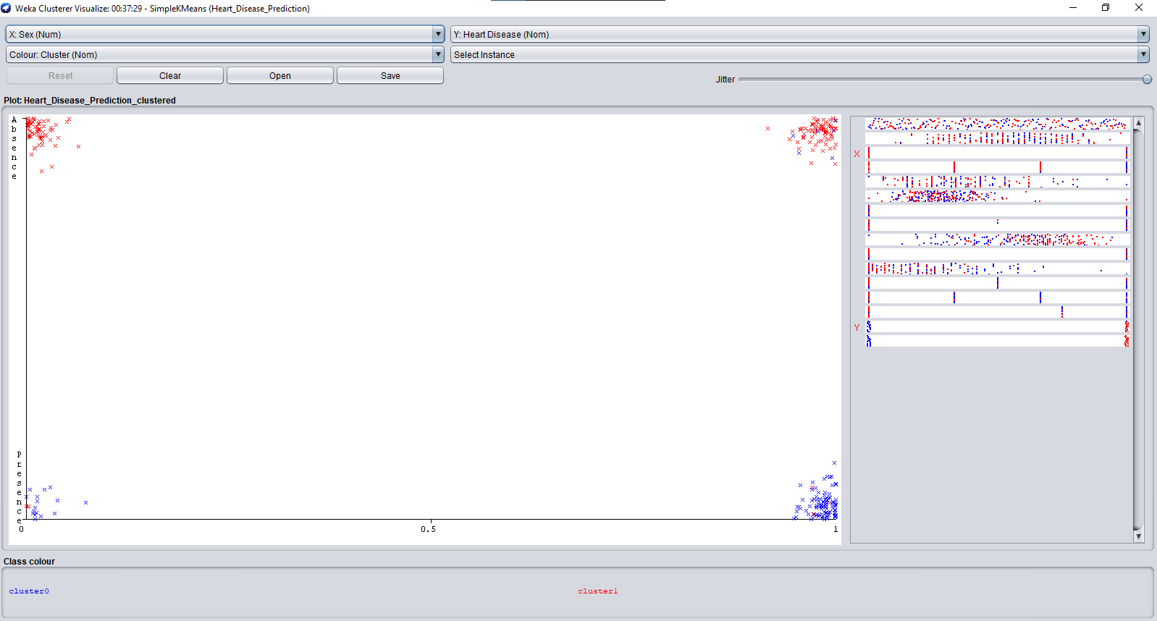

* 1. **CHEST PAIN TYPE VS HEART DISEASE:**

When you have chest pain, your first thought may be that you’re having a [heart attack](https://www.healthline.com/health/heart-attack). While chest pain is a [well-established sign](https://www.healthline.com/health/heart-disease/warning-signs-heart-attack) of a heart attack, it can also be caused by many other less serious conditions.

The following are heart-related causes of chest pain:

[Heart attack](https://www.healthline.com/health/heart-disease/types-of-heart-attacks), which is a blockage of blood flow to the heart [angina](https://www.healthline.com/health/stable-angina), which is chest pain caused by blockages in the blood vessels leading to your heart

[Pericarditis](https://www.healthline.com/health/pericarditis), which is an inflammation of the sac around the heart

[Myocarditis](https://www.healthline.com/health/heart-disease/myocarditis), which is an inflammation of the heart muscle

[Cardiomyopathy](https://www.healthline.com/health/heart-disease/cardiomyopathy), which is a disease of the heart muscle

[Aortic dissection](https://www.healthline.com/health/heart-disease/aortic-dissection), which is a rare condition involving a tear of the aorta, the large vessel that comes off of the heart.

Seek emergency treatment immediately if you think you may be having a heart attack and especially if your chest pain is new, unexplained, or lasts more than a few moments.

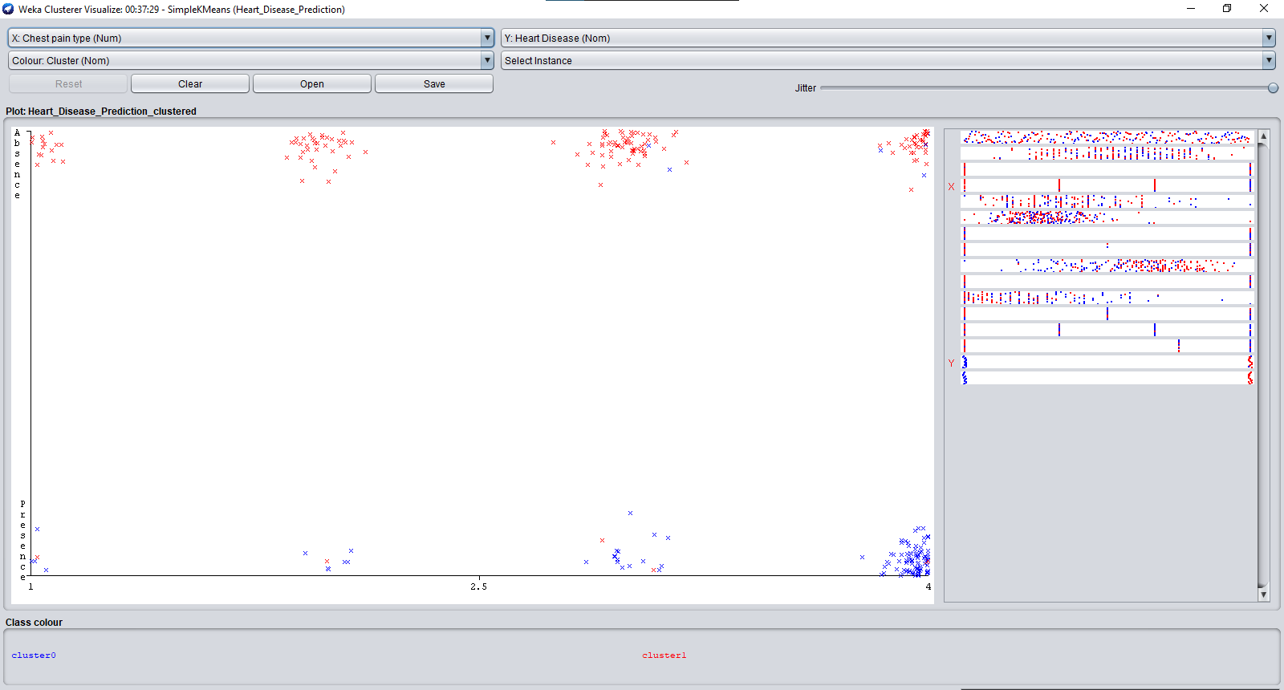

## **BP VS HEART DISEASE:**

High blood pressure, also called hypertension, is blood pressure that is higher than normal. Your blood pressure changes throughout the day based on your activities. Having blood pressure measures consistently above normal may result in a diagnosis of high blood pressure (or hypertension).

The higher your blood pressure levels, the more risk you have for other health problems, such as [heart disease](https://www.cdc.gov/heartdisease/about.htm), [heart attack](https://www.cdc.gov/heartdisease/heart_attack.htm), and [stroke](https://www.cdc.gov/stroke/about.htm).

Your health care team can diagnose high blood pressure and make treatment decisions by reviewing your systolic and diastolic blood pressure levels and comparing them to levels found in certain guidelines.

The guidelines used to diagnose high blood pressure may differ from health care professional to health care professional:

* Some health care professionals diagnose patients with high blood pressure if their blood pressure is consistently 140/90 mm Hg or higher.
* Other health care professionals diagnose patients with high blood pressure if their blood pressure is consistently 130/80 mm Hg or higher.

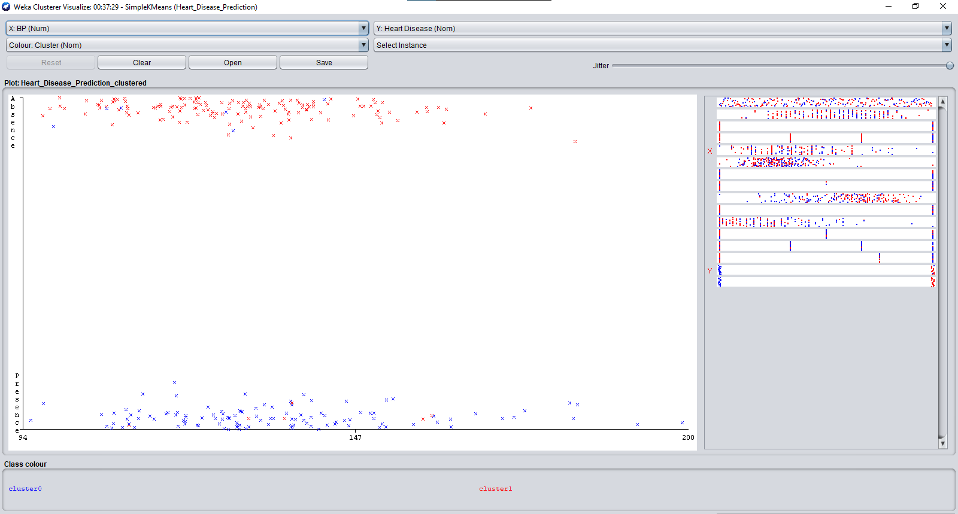

## **CHOLESTROL VS HEART DISEASE:**

## When there is too much cholesterol in your [blood](https://www.webmd.com/heart/anatomy-picture-of-blood), it builds up in the walls of your [arteries](https://www.webmd.com/heart/picture-of-the-arteries), causing a process called [atherosclerosis](https://www.webmd.com/heart-disease/what-is-atherosclerosis), a form of [heart disease](https://www.webmd.com/heart-disease/ss/slideshow-visual-guide-to-heart-disease). The arteries become narrowed and [blood](https://www.webmd.com/a-to-z-guides/rm-quiz-blood-basics) flow to the [heart](https://www.webmd.com/heart/picture-of-the-heart) muscle is slowed down or blocked. The blood carries oxygen to the [heart](https://www.webmd.com/heart-disease/rm-quiz-know-heart), and if not enough blood and oxygen reach your heart, you may suffer [chest pain](https://www.webmd.com/pain-management/guide/whats-causing-my-chest-pain). If the blood supply to a portion of the heart is completely cut off by a blockage, the result is a [heart attack](https://www.webmd.com/heart-disease/guide/heart-disease-heart-attacks).

## There are two forms of cholesterol that many people are familiar with: Low-density lipoprotein ([LDL](https://www.webmd.com/heart-disease/your-heart-health-20/ldl-cholesterol-bad-cholesterol) or "bad" cholesterol) and high-density lipoprotein (HDL or "good" cholesterol.) These are the forms in which cholesterol travels in the blood.

[LDL](https://www.webmd.com/cholesterol-management/ss/slideshow-cholesterol-lowering-foods) is the main source of artery-clogging plaque. HDL actually works to clear cholesterol from the blood. [Triglycerides](https://www.webmd.com/cholesterol-management/lowering-triglyceride-levels) are another fat in our bloodstream. Research is now showing that high levels of [triglycerides](https://www.webmd.com/cholesterol-management/high-triglycerides-treatment-12/slideshow-triglycerides-tips) may also be linked to [heart disease](https://www.webmd.com/heart-disease/video/bernstein-heart-disease-kill).

High cholesterol itself does not cause any symptoms, so many people are unaware that their [cholesterol levels](https://www.webmd.com/cholesterol-management/guide/understanding-numbers) are too high. Therefore, it is important to find out what your [cholesterol numbers](https://www.webmd.com/cholesterol-management/finding-the-ideal-cholesterol-ratio) are. Lowering cholesterol levels that are too high lessens the risk for developing heart disease and reduces the chance of a [heart attack](https://www.webmd.com/heart-disease/ss/slideshow-heart-attack) or dying of heart disease, even if you already have it.

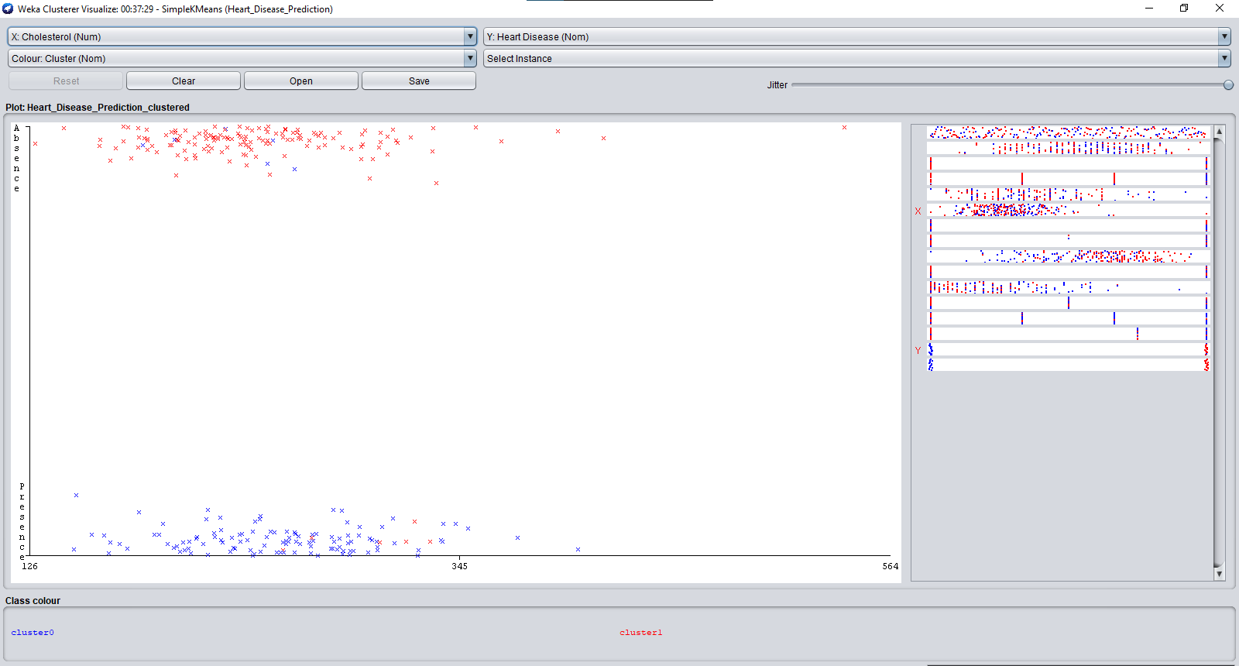

## **FBS OVER 120 VS HEART DISEASE:**

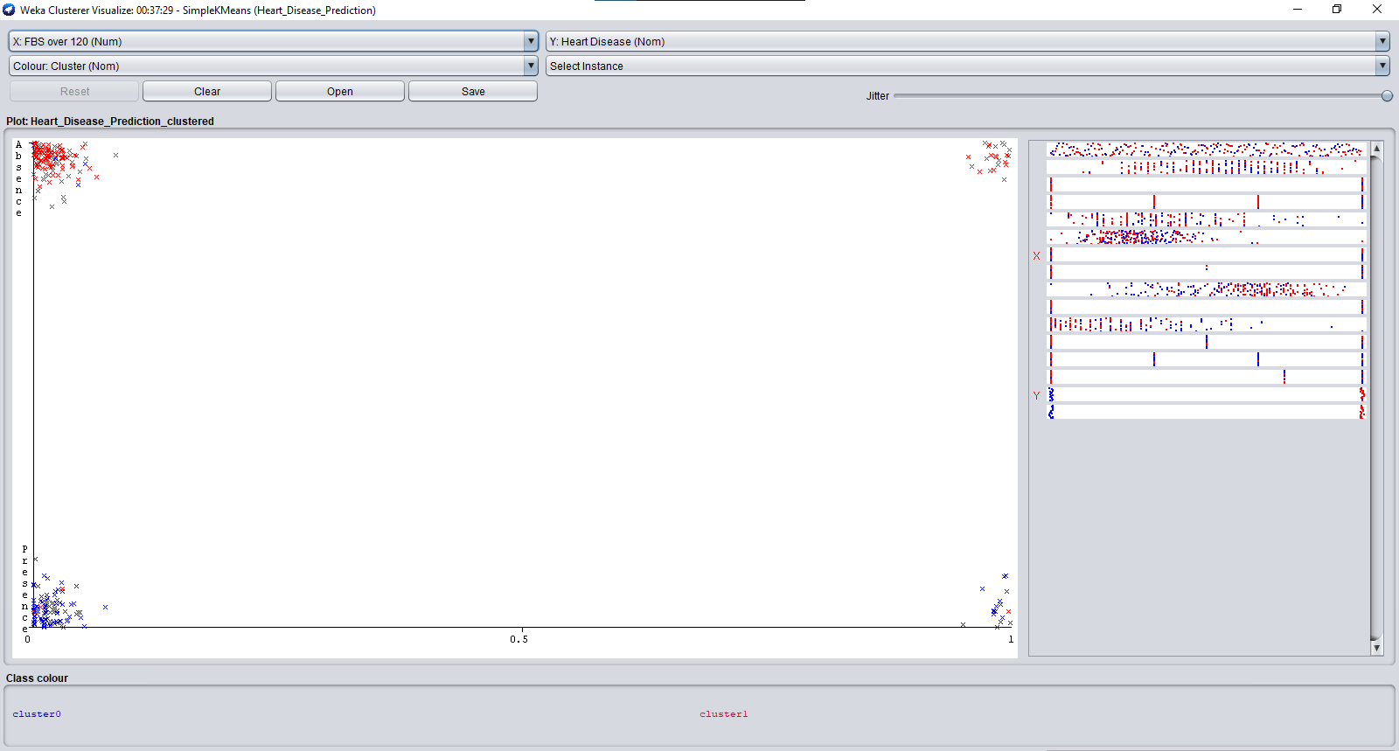

## **EKG RESULTS VS HEART DISEASE:**

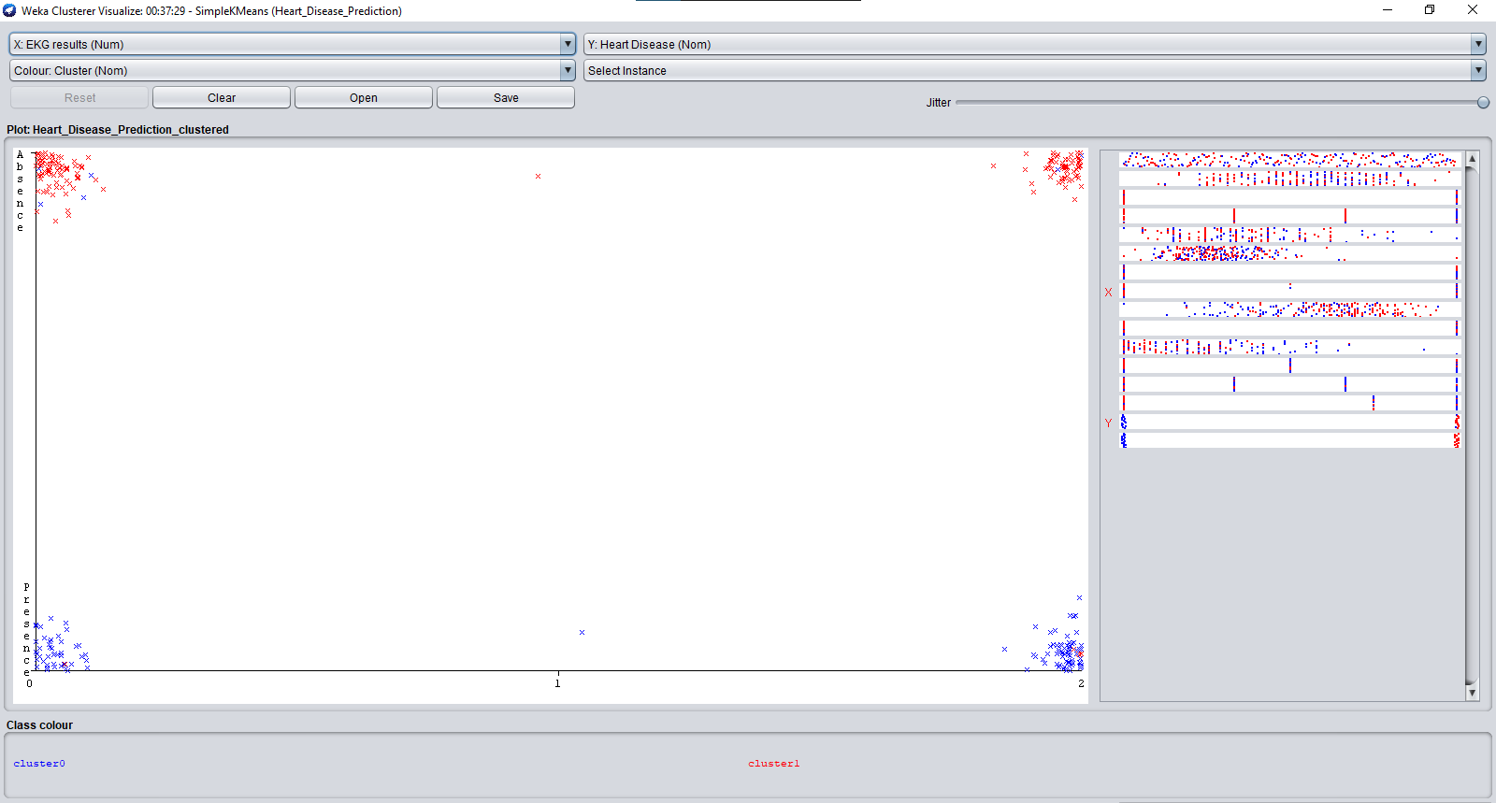

## **MAX HR VS HEART DISEASE:**

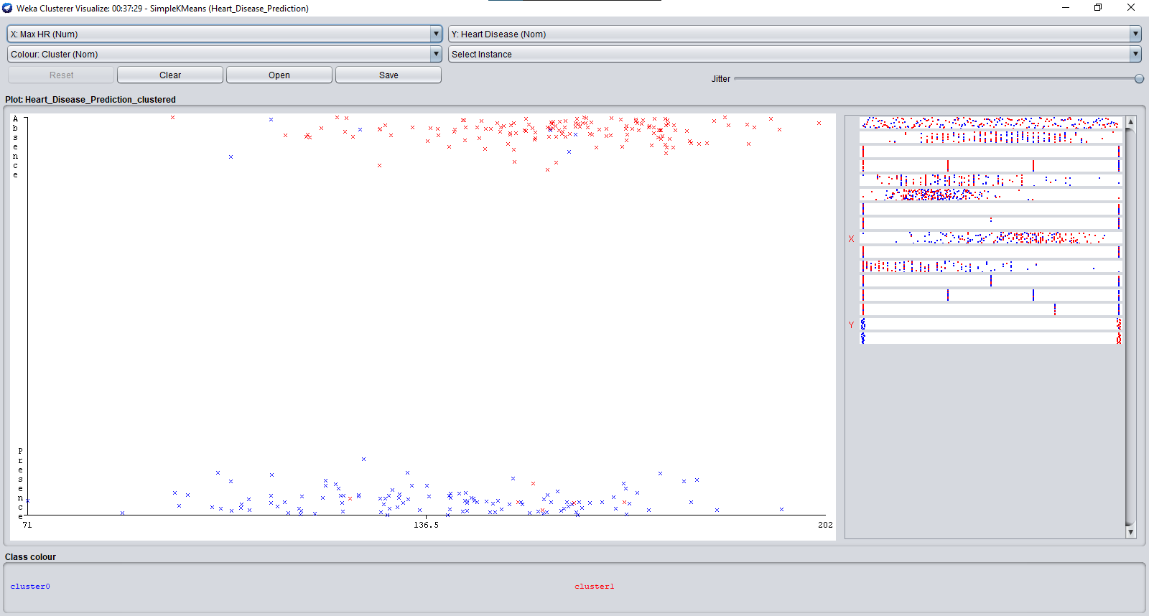

* 1. **EXERCISE ANGINA VS HEART DISEASE**

Angina is the medical term for chest pain or discomfort caused by a temporary disruption in the flow of blood and oxygen to the heart. People describe angina discomfort as a squeezing, suffocating or burning feeling – usually in the centre of the chest, behind the breastbone.

**Key facts about angina:**

* It’s your heart telling you that it needs more oxygen.
* You need to stop what you’re doing, rest and/or take your medication.
* It’s almost always a sign that you have blocked arteries and heart disease.
* It’s usually a short-lived event – lasting for a few minutes.
* It’s a warning that without treatment, you are at risk for [heart attack](http://www.heartandstroke.ca/heart/conditions/heart-attack), irregular heartbeat ([arrhythmia](http://www.heartandstroke.ca/heart/conditions/arrhythmia)) and cardiac arrest ([cardiopulmonary arrest](http://www.heartandstroke.ca/heart/conditions/cardiac-arrest)).

All chest pain should be checked out by a healthcare provider.

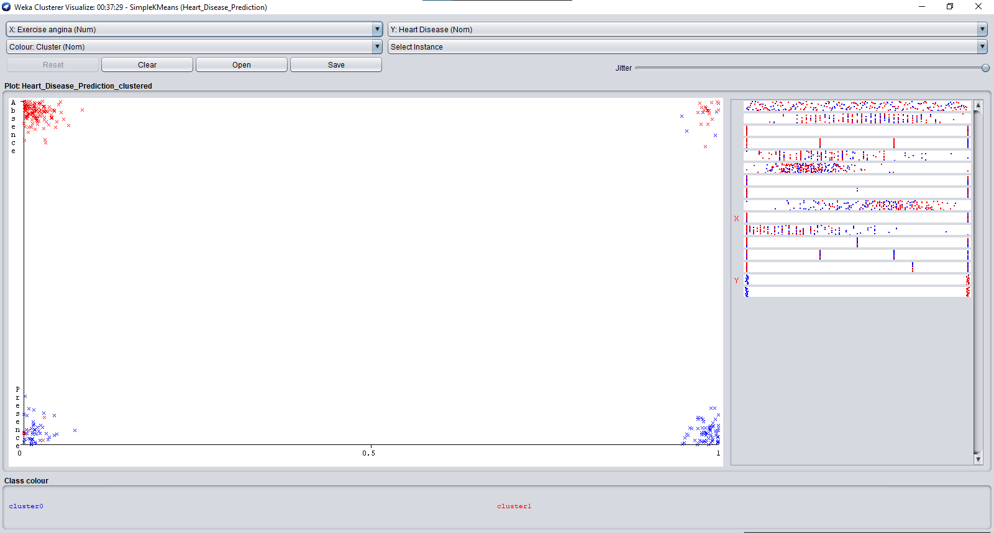

## **ST DEPRESSION VS HEART DISEASE:**

Depression and heart disease are among the most disabling diseases we face. They are both very widespread among the general population and often occur simultaneously in the same individual.

There is thought to be a two-way relationship between heart disease and depression:

A percentage of people with no history of depression become depressed after a heart attack or after developing heart failure. And people with depression but no previously detected heart disease, seem to develop heart disease at a higher rate than the general population.

It is somewhat hard to prove that heart disease directly leads to the development of a first-ever episode of depression. That is because some people who have had previous episodes of depression may not have it formally diagnosed until they see their doctor for heart problems.

“What we can say with certainty is that depression and heart disease often occur together,” says Dr. Roy Ziegelstein, vice dean for education at the Johns Hopkins University School of Medicine . “About one in five who have a heart attack are found to have depression soon after the heart attack. And it’s at least as prevalent in people who suffer heart failure.”

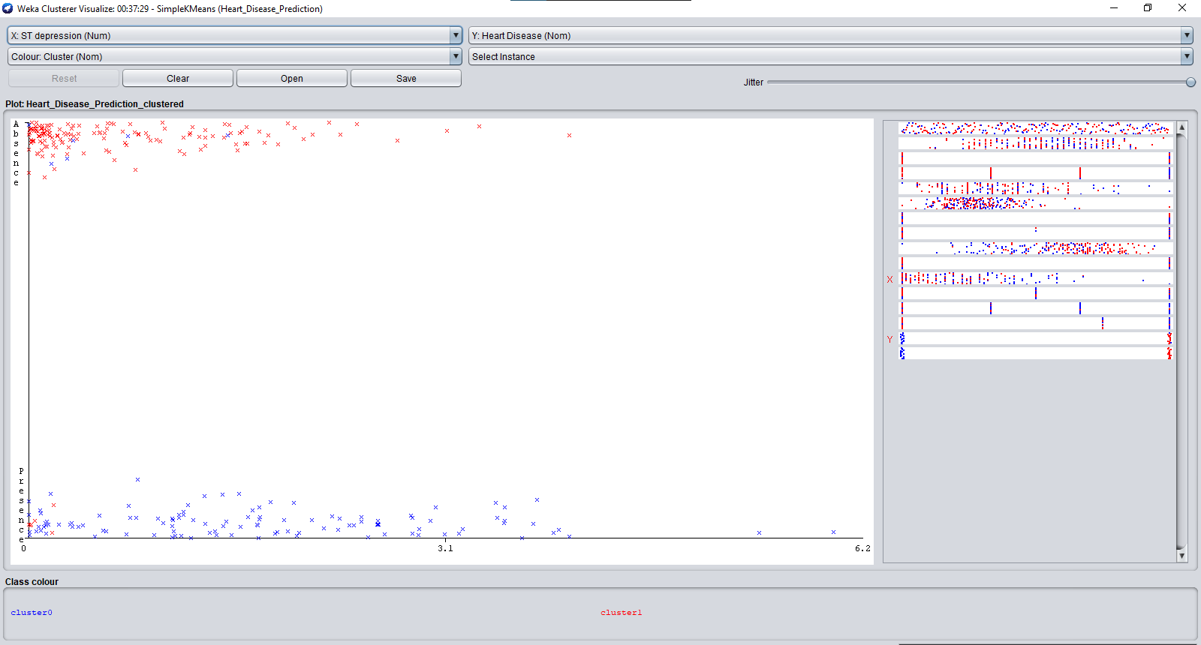

## **SLOPE OF ST VS HEART DISEASE:**

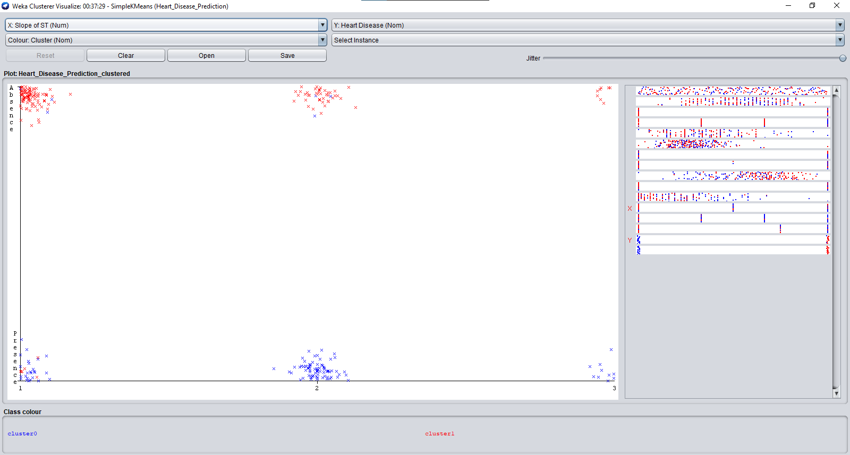

## **NO. OF VESSELS FLURO VS HEART DISEASE:**

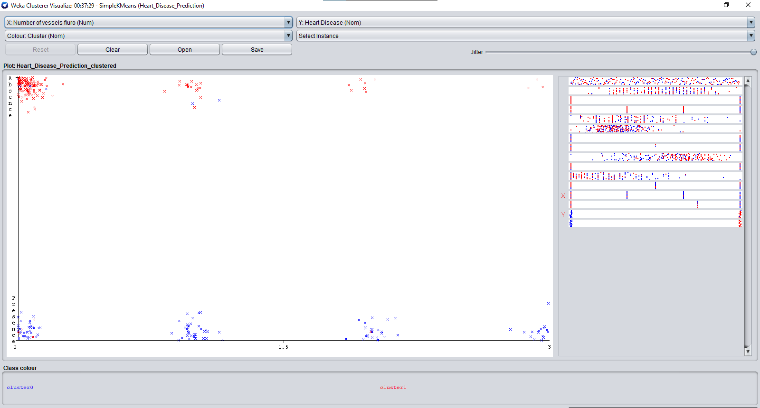

## **THALLIUM VS HEART DISEASE**

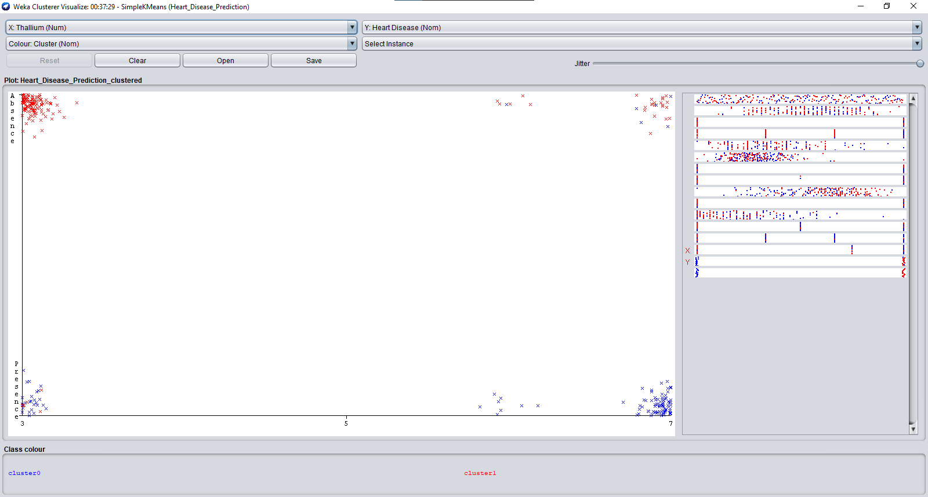

## **PLOT MATRIX**

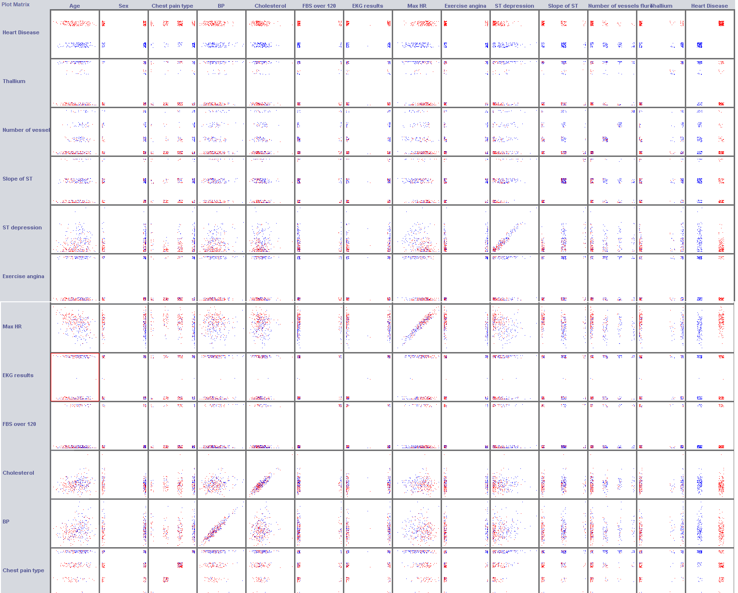

**MODEL DETAILS:**

Our project is about detection heart disease which is based on 14 attributes in which the ‘age’ attribute shows the patient’s age, sex shows gender, chest pain whose ratio is from 1 to 4 shows patient’s condition, BP shows blood pressure, cholestrol shows the patient’s cholestrol. Slope of ST shows PQRST, Exercise angina shows if a person do exercise so he’s got angina attack or not where coloumn N (presence,absence) shows does patient have heart disease or not.

In our project we have applied K-means,decision tree and confusion matrix then we have visualised heart disease of attributes through data visualisation and at the end we have plotted some plot matrix.

**K-MEANS:**

**Kmeans** algorithm is an iterative algorithm that tries to partition the dataset into Kpre-defined distinct non-overlapping subgroups (clusters) where each data point belongs to **only one group**. It tries to make the intra-cluster data points as similar as possible while also keeping the clusters as different (far) as possible. It assigns data points to a cluster such that the sum of the squared distance between the data points and the cluster’s centroid (arithmetic mean of all the data points that belong to that cluster) is at the minimum. The less variation we have within clusters, the more homogeneous (similar) the data points are within the same cluster.

The way kmeans algorithm works is as follows:

Specify number of clusters *K*.

Initialize centroids by first shuffling the dataset and then randomly selecting *K*data points for the centroids without replacement.

Keep iterating until there is no change to the centroids. i.e assignment of data points to clusters isn’t changing.

Compute the sum of the squared distance between data points and all centroids.

Assign each data point to the closest cluster (centroid).

Compute the centroids for the clusters by taking the average of the all data points that belong to each cluster.

The approach kmeans follows to solve the problem is called **Expectation-Maximization**. The E-step is assigning the data points to the closest cluster. The M-step is computing the centroid of each cluster. Below is a break down of how we can solve it mathematically (feel free to skip it).

The objective function is:

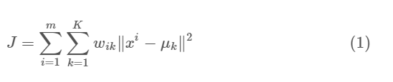

where wik=1 for data point xi if it belongs to cluster *k*; otherwise, wik=0. Also, μk is the centroid of xi’s cluster.

It’s a minimization problem of two parts. We first minimize J w.r.t. wik and treat μk fixed. Then we minimize J w.r.t. μk and treat wik fixed. Technically speaking, we differentiate J w.r.t. wik first and update cluster assignments (*E-step*). Then we differentiate J w.r.t. μk and recompute the centroids after the cluster assignments from previous step (*M-step*). Therefore, E-step is:

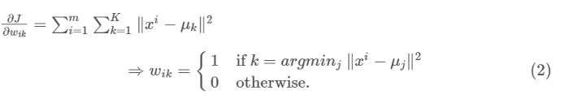

In other words, assign the data point xi to the closest cluster judged by its sum of squared distance from cluster’s centroid.

And M-step is:

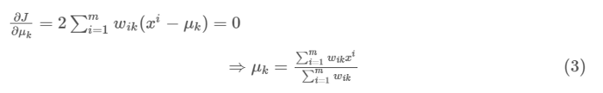

Which translates to recomputing the centroid of each cluster to reflect the new assignments.

Few things to note here:

* Since clustering algorithms including kmeans use distance-based measurements to determine the similarity between data points, it’s recommended to standardize the data to have a mean of zero and a standard deviation of one since almost always the features in any dataset would have different units of measurements such as age vs income.
* Given kmeans iterative nature and the random initialization of centroids at the start of the algorithm, different initializations may lead to different clusters since kmeans algorithm may *stuck in a local optimum and may not converge to global optimum*. Therefore, it’s recommended to run the algorithm using different initializations of centroids and pick the results of the run that that yielded the lower sum of squared distance.
* Assignment of examples isn’t changing is the same thing as no change in within-cluster variation:

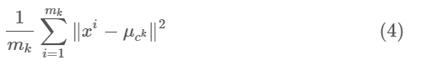

**CONFUSION MATRIX:**

A confusion matrix is a summary of prediction results on a classification problem.

The number of correct and incorrect predictions are summarized with count values and broken down by each class. This is the key to the confusion matrix.

**The confusion matrix shows the ways in which your classification model**  
**is confused when it makes predictions.**

It gives you insight not only into the errors being made by your classifier but more importantly the types of errors that are being made.

It is this breakdown that overcomes the limitation of using classification accuracy alone.

Confusion matrix is a table that defines the performance of algorithm. It visualises the performance of algorithm. In confusion matrix 4 major points are used which are:

1. True positive (TP)
2. True negative (TN)
3. False positive (FP)
4. False negative (FN)

**CALCULATE A CONFUSION MATRIX:**

Below is the process for calculating a confusion Matrix.

1. You need a test dataset or a validation dataset with expected outcome values.
2. Make a prediction for each row in your test dataset.
3. From the expected outcomes and predictions count:
   1. The number of correct predictions for each class.
   2. The number of incorrect predictions for each class, organized by the class that was predicted.

These numbers are then organized into a table, or a matrix as follows:

* Expected down the side: Each row of the matrix corresponds to a predicted class.
* Predicted across the top: Each column of the matrix corresponds to an actual class.

Time taken to build model: 0.02 seconds

=== Stratified cross-validation ===

=== Summary ===

Correctly Classified Instances 60 60 %

Incorrectly Classified Instances 40 40 %

Kappa statistic 0.4235

Mean absolute error 0.2078

Root mean squared error 0.4008

Relative absolute error 59.5501 %

Root relative squared error 96.0648 %

Total Number of Instances 100

=== Detailed Accuracy By Class ===

TP Rate FP Rate Precision Recall F-Measure ROC Area Class

0.711 0.255 0.696 0.711 0.703 0.796 c0

0.6 0.106 0.5 0.6 0.545 0.807 c1

0.381 0.139 0.421 0.381 0.4 0.767 c2

0.579 0.074 0.647 0.579 0.611 0.748 c3

Weighted Avg. 0.6 0.174 0.599 0.6 0.598 0.783

=== Confusion Matrix ===

a b c d <-- classified as

32 0 8 5 | a = c0

4 9 1 1 | b = c1

6 7 8 0 | c = c2

4 2 2 11 | d = c3

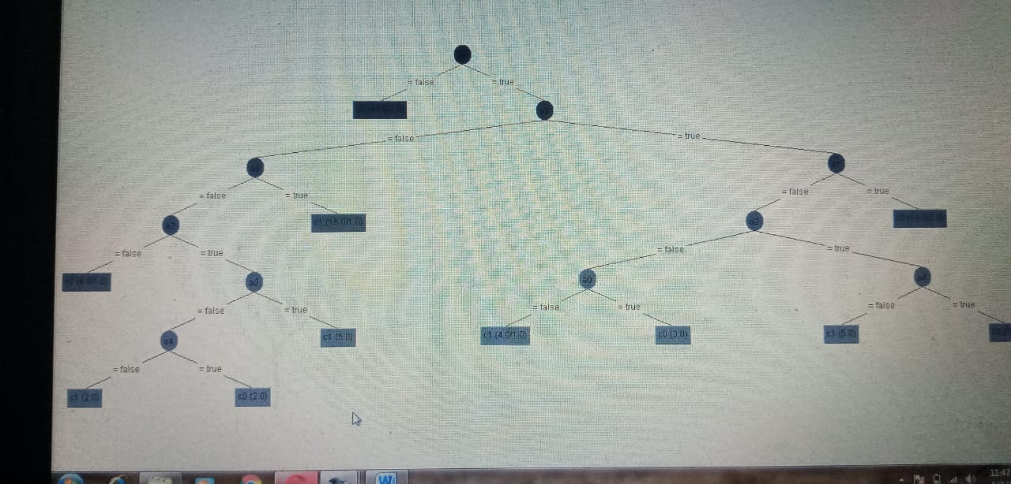

**6.1. COMPARISON:**

**LIFE WITHOUT HEART DISEASE:**

In this world, life is a very precious gift for every single person by God. He is given us so many things like food, trees, sky, mountain, sea etc. Among all these things He’s also given us health. Good health is also a gift for all of us. Because of good health (a person has no disease) we can enjoy our life totally and completely. Because of good health we can face every ups and downs in our lives without facing any diificulty regarding our health.

**LIFE WITH HEART DISEASE:**

Heart disease is a major disease for both men and women. In human’s heart , there are 4 arteries in which a single artery shouldn’t be blocked. If one wall is blocked means he has a serious problem in heart, if 2 walls are blocked means he has more serious problem, if 3 then it means he has major heart problem.

Disease doesn’t depend upon age and gender. Men and women both can be sick with less age. Men progress to heart attacks faster than women because women have more stamina and power than men. Men who are above 50 have more chances of heart disease than woman.

In a nutshell, if a person has heart disease means he’s not much that active or healthy person rather than the person who has no heart disease.

Living with heart disease isn't simple. But it's something millions of people manage to do.

# **CONCLUSION & REFERENCES:**

**CONCLUSION:**

Following the algorithm and technique, we can deduce the presence of heart disease on the basis of some attributes. In light of this model, we can predict but prediction can’t be 100% true. Therefore, we will increase the set of attributes for more accurate prediction in near future.

**REFERENCES:**

* kaggle.com/ronitf/heart-disease-uci/version/1
* M. Dumont et al, [Fast multi-class image annotation with random subwindows and multiple output randomized trees](http://www.montefiore.ulg.ac.be/services/stochastic/pubs/2009/DMWG09/dumont-visapp09-shortpaper.pdf), International Conference on Computer Vision Theory and Applications 2009
* [www.sciencedirect.com/topics/engineering/confusion-matrix](http://www.sciencedirect.com/topics/engineering/confusion-matrix)
* [stanford.edu/~cpiech/cs221/handouts/kmeans.html](https://stanford.edu/~cpiech/cs221/handouts/kmeans.html)